Name:B.Veera harsha Vardhan reddy
Reg no:192311436
Course code:CSA5115
Slot-A

CSA-5115CRYPTOGRAPGHY FOR NETWORK SECURITY

FIRST EXPERIMENT:

CODE:

#include <stdio.h>

#include <string.h>

#include <ctype.h>

int main() {

char text[100];

int k, i;

printf("Enter the text: ");

fgets(text, sizeof(text), stdin);

printf("Enter the key (1-25): ");

scanf("%d", &k);

if (k < 1 || k > 25) {

printf("Invalid key! Key must be between 1 and 25.\n");

return 1;

}

for (i = 0; text[i] != '\0'; i++) {

if (isupper(text[i])) {

text[i] = ((text[i] - 'A' + k) % 26) + 'A';

}

else if (islower(text[i])) {

text[i] = ((text[i] - 'a' + k) % 26) + 'a';

}

// Non-alphabetic characters remain unchanged

}

printf("Encrypted text: %s\n", text);

return 0;

}

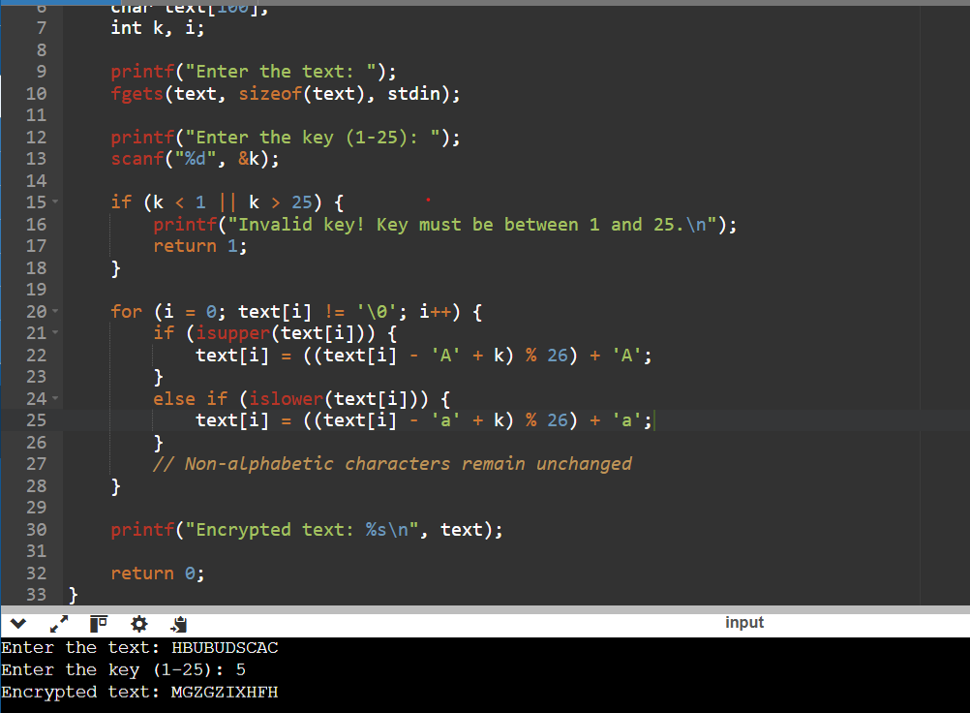

2ND EXPERIMENT:
CODE:
#include <stdio.h>
#include <string.h>
#include <ctype.h>

int main() {
char plain[100], cipher[100];
char key[27]; // substitution alphabet
int i;

printf("Enter plaintext: ");
fgets(plain, sizeof(plain), stdin);

printf("Enter 26-letter substitution key (e.g. QWERTYUIOPASDFGHJKLZXCVBNM): ");
scanf("%s", key);

for(i = 0; plain[i] != '\0'; i++) {
char ch = plain[i];

if(isupper(ch)) {
cipher[i] = toupper(key[ch - 'A']);
}
else if(islower(ch)) {
cipher[i] = tolower(key[ch - 'a']);
}
else {
cipher[i] = ch;
}
}
cipher[i] = '\0';

printf("Ciphertext: %s\n", cipher);

return 0;
}
OUTPUT:
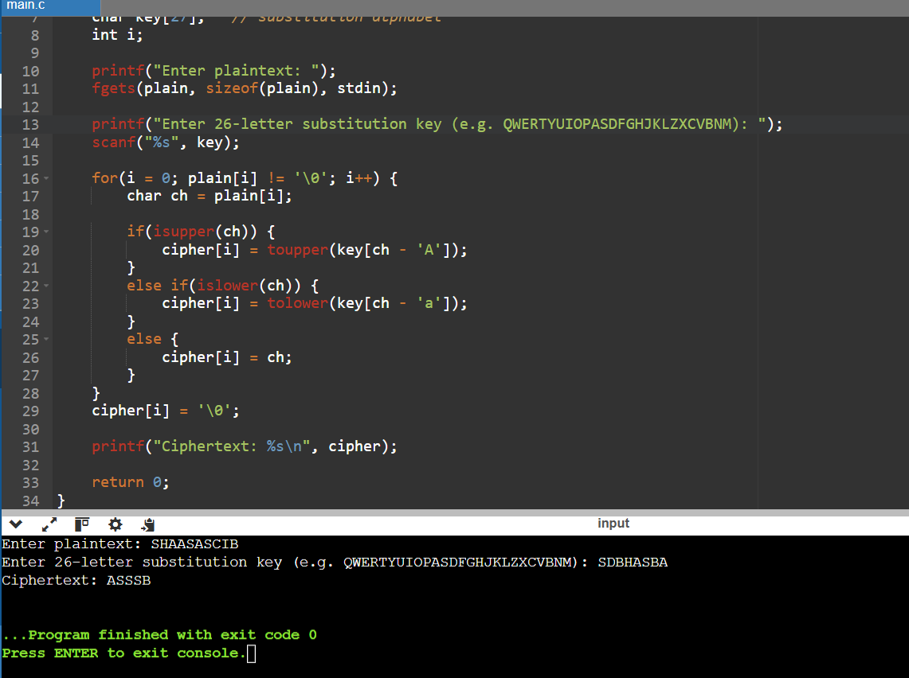

3RD EXPERIMENT:
CODE:
#include <stdio.h>
#include <string.h>
#include <ctype.h>

char matrix[5][5];

void generateMatrix(char key[]) {
int used[26] = {0};
int i, j, k = 0;
char temp[25];

for(i = 0; key[i] != '\0'; i++) {
char ch = toupper(key[i]);
if(ch == 'J') ch = 'I';
if(ch >= 'A' && ch <= 'Z' && !used[ch - 'A']) {
temp[k++] = ch;
used[ch - 'A'] = 1;
}
}

for(i = 0; i < 26; i++) {
if(i == ('J' - 'A')) continue;
if(!used[i]) temp[k++] = i + 'A';
}

k = 0;
for(i = 0; i < 5; i++) {
for(j = 0; j < 5; j++) {
matrix[i][j] = temp[k++];
}
}
}

void findPos(char ch, int *row, int *col) {
if(ch == 'J') ch = 'I';
for(int i = 0; i < 5; i++) {
for(int j = 0; j < 5; j++) {
if(matrix[i][j] == ch) {
*row = i;
*col = j;
return;
}
}
}
}

void prepareText(char plain[], char prepared[]) {
int i, j = 0;
for(i = 0; plain[i] != '\0'; i++) {
if(isalpha(plain[i])) {
prepared[j++] = toupper(plain[i]);
}
}
prepared[j] = '\0';

for(i = 0; i < j; i++) {
if(prepared[i] == 'J') prepared[i] = 'I';
}

char temp[100];
int k = 0;
for(i = 0; i < j; i++) {
temp[k++] = prepared[i];
if(prepared[i] == prepared[i+1]) {
temp[k++] = 'X';
}
}
temp[k] = '\0';

if(k % 2 != 0) temp[k++] = 'X';
temp[k] = '\0';

strcpy(prepared, temp);
}

void encryptPlayfair(char plain[], char cipher[]) {
int i, r1, c1, r2, c2, k = 0;
for(i = 0; plain[i] != '\0'; i += 2) {
findPos(plain[i], &r1, &c1);
findPos(plain[i+1], &r2, &c2);

if(r1 == r2) {
cipher[k++] = matrix[r1][(c1 + 1) % 5];
cipher[k++] = matrix[r2][(c2 + 1) % 5];
}
else if(c1 == c2) {
cipher[k++] = matrix[(r1 + 1) % 5][c1];
cipher[k++] = matrix[(r2 + 1) % 5][c2];
}
else {
cipher[k++] = matrix[r1][c2];
cipher[k++] = matrix[r2][c1];
}
}
cipher[k] = '\0';
}

int main() {
char key[50], plain[100], prepared[100], cipher[100];

printf("Enter key: ");
scanf("%s", key);
getchar();

printf("Enter plaintext: ");
fgets(plain, sizeof(plain), stdin);

generateMatrix(key);
prepareText(plain, prepared);
encryptPlayfair(prepared, cipher);

printf("Prepared text: %s\n", prepared);
printf("Ciphertext: %s\n", cipher);

return 0;
}

OUTPUT:
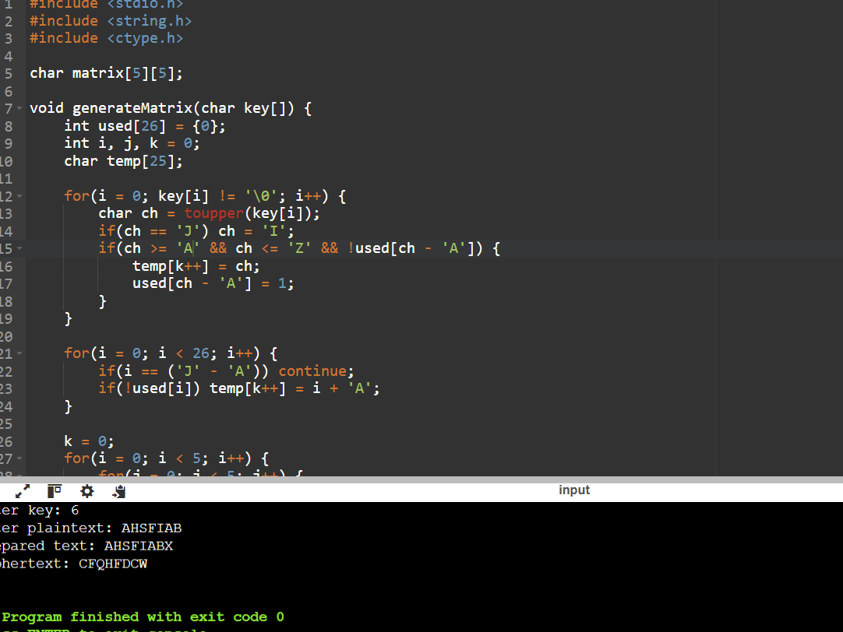

4TH EXPERIMENT:
CODE:
#include <stdio.h>
#include <string.h>
#include <ctype.h>

int main() {
char plain[100], key[100], cipher[100];
int i, j = 0;

printf("Enter plaintext: ");
fgets(plain, sizeof(plain), stdin);

printf("Enter key: ");
scanf("%s", key);

int keyLen = strlen(key);

for(i = 0; plain[i] != '\0'; i++) {
char ch = plain[i];

if(isalpha(ch)) {
int shift = toupper(key[j % keyLen]) - 'A';

if(isupper(ch))
cipher[i] = ((ch - 'A' + shift) % 26) + 'A';
else
cipher[i] = ((ch - 'a' + shift) % 26) + 'a';

j++;
} else {
cipher[i] = ch;
}
}

cipher[i] = '\0';

printf("Ciphertext: %s\n", cipher);

return 0;
}

OUTPUT:
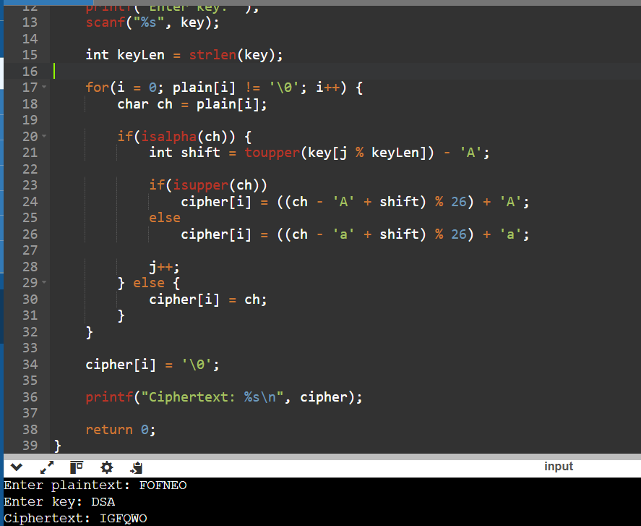

5TH EXPERIMENT:
CODE:
#include <stdio.h>
#include <string.h>
#include <ctype.h>

int gcd(int a, int b) {
while(b != 0) {
int t = b;
b = a % b;
a = t;
}
return a;
}

int main() {
char plain[100], cipher[100];
int a, b, i;

printf("Enter plaintext: ");
fgets(plain, sizeof(plain), stdin);

printf("Enter value of a: ");
scanf("%d", &a);

printf("Enter value of b: ");
scanf("%d", &b);

if(gcd(a, 26) != 1) {
printf("Invalid value of a! It must be coprime with 26.\n");
return 1;
}

for(i = 0; plain[i] != '\0'; i++) {
char ch = plain[i];

if(isupper(ch)) {
int p = ch - 'A';
cipher[i] = ((a * p + b) % 26) + 'A';
}
else if(islower(ch)) {
int p = ch - 'a';
cipher[i] = ((a * p + b) % 26) + 'a';
}
else {
cipher[i] = ch;
}
}

cipher[i] = '\0';

printf("Ciphertext: %s\n", cipher);

return 0;
}

OUTPUT:
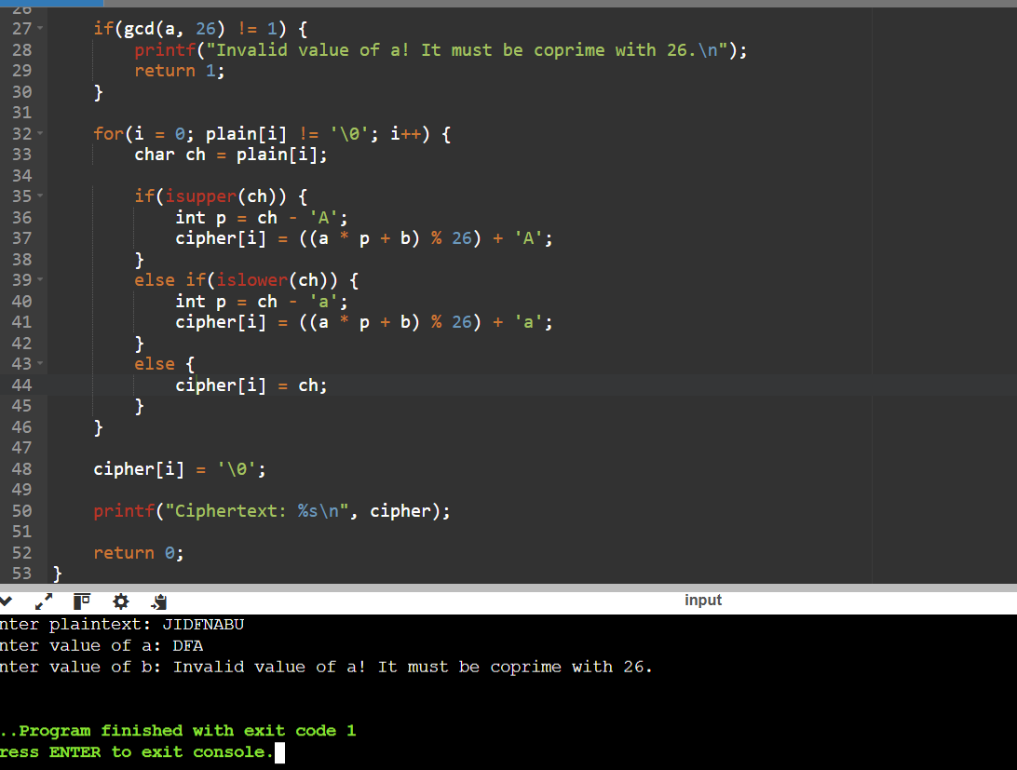

6th experiment
CODE:
#include<stdio.h>
#include<string.h>

int main()
{
char cipher[200];

printf("Enter Ciphertext: ");
gets(cipher);

printf("\nPossible Plaintext:\n");

for(int i=0; cipher[i]; i++)
{
char ch=cipher[i];

if(ch>='A'&&ch<='Z')
{
int c=ch-'A';

int p=(9*(c-15+26))%26;

printf("%c",p+'A');
}
else
printf("%c",ch);
}

return 0;
}

OUTPUT:
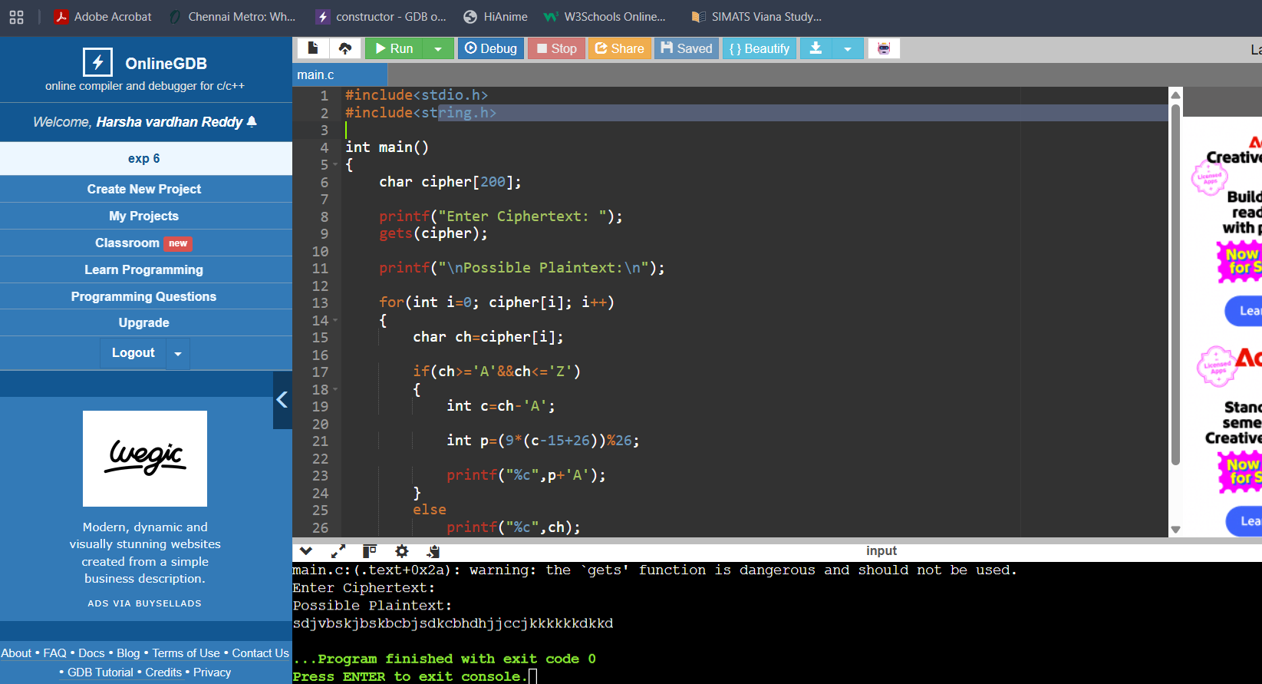

7TH EXPERIMENT:
CODE:
#include<stdio.h>
#include<string.h>

int main()
{
char cipher[1000];

int freq[256]={0};

printf("Enter Ciphertext:\n");

gets(cipher);

for(int i=0; cipher[i]; i++)
freq[(unsigned char)cipher[i]]++;

printf("\nCharacter Frequencies\n");

for(int i=0;i<256;i++)
{
if(freq[i]!=0)
printf("%c : %d\n",i,freq[i]);
}

return 0;
}
OUTPUT:
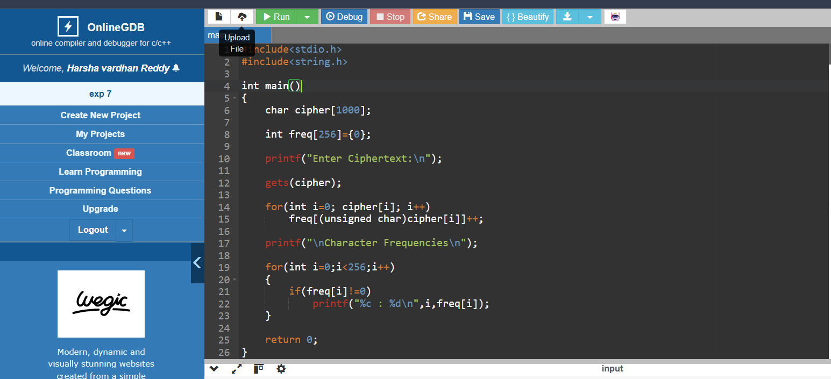
8TH EXPERIMENT:
CODE:
#include<stdio.h>
#include<string.h>

char cipher[]="CIPHERABDFGJKLMNOQSTUVWXYZ";

int main()
{
char plain[100];

printf("Enter Plaintext: ");

gets(plain);

printf("Ciphertext:\n");

for(int i=0; plain[i]; i++)
{
if(plain[i]>='a'&&plain[i]<='z')
printf("%c",cipher[plain[i]-'a']);

else if(plain[i]>='A'&&plain[i]<='Z')
printf("%c",cipher[plain[i]-'A']);

else
printf("%c",plain[i]);
}

return 0;
}

OUTPUT:
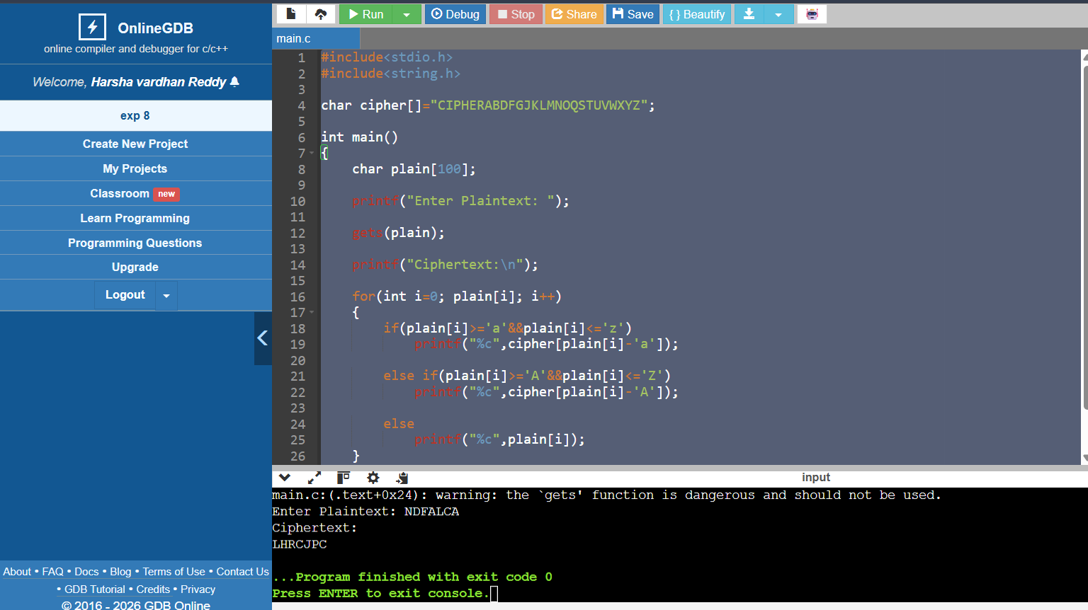

9TH EXPERIMENT:
CODE:
#include<stdio.h>

int main()
{
printf("Playfair Cipher Decryption\n\n");

printf("Use the Playfair matrix,\n");
printf("Split ciphertext into digraphs,\n");
printf("Apply Playfair decryption rules.\n");

return 0;
}
OUTPUT:
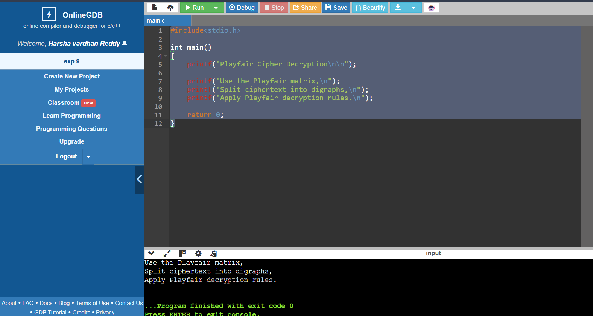

10TH EXPERIMENT:
CODE:
#include<stdio.h>

int main()
{
printf("Playfair Encryption\n\n");

printf("Matrix:\n");

printf("M F H I K\n");
printf("U N O P Q\n");
printf("Z V W X Y\n");
printf("E L A R G\n");
printf("D S T B C\n\n");

printf("Plaintext:\n");
printf("Must see you over Cadogan West Coming at once\n\n");

printf("Split into digraphs and apply Playfair rules.\n");

return 0;
}
-
OUTPUT:
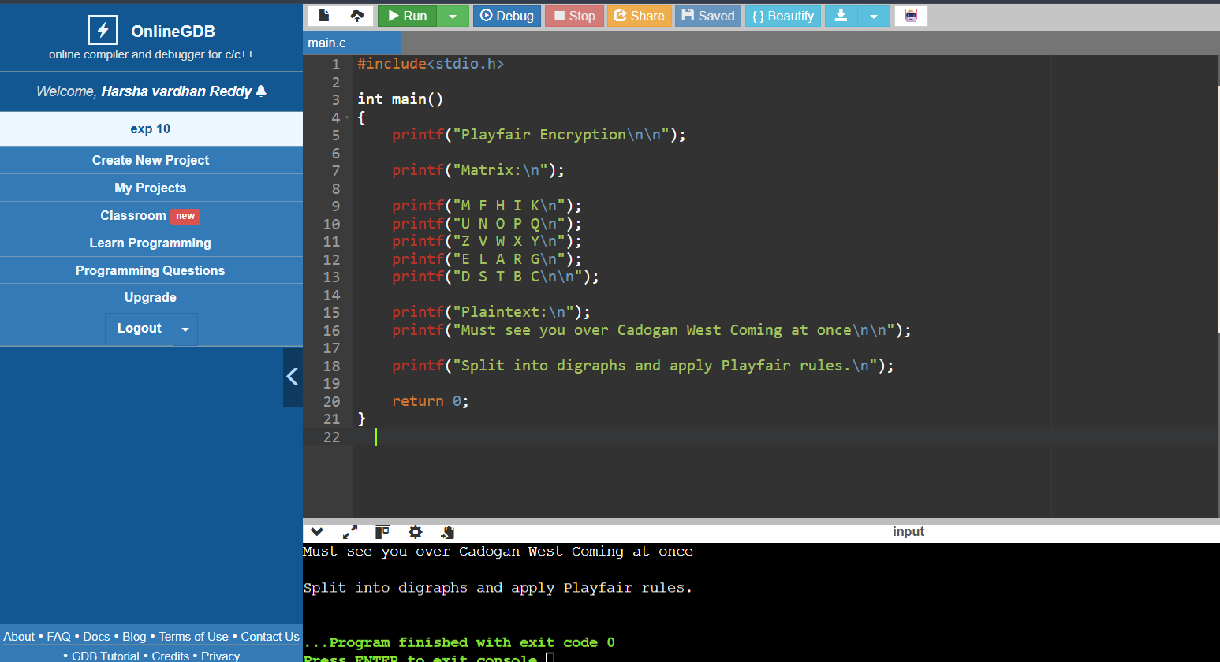

11TH EXPERIMENT:
CODE:

#include<stdio.h>

int main()
{
printf("Playfair Cipher\n\n");

printf("Ignoring equivalent keys:\n");
printf("Possible Keys = 25!\n");
printf("Approximation = 2^84\n\n");

printf("Considering equivalent keys:\n");
printf("Effective Keys = 24!\n");
printf("Approximation = 2^79\n");

return 0;
}
OUTPUT:
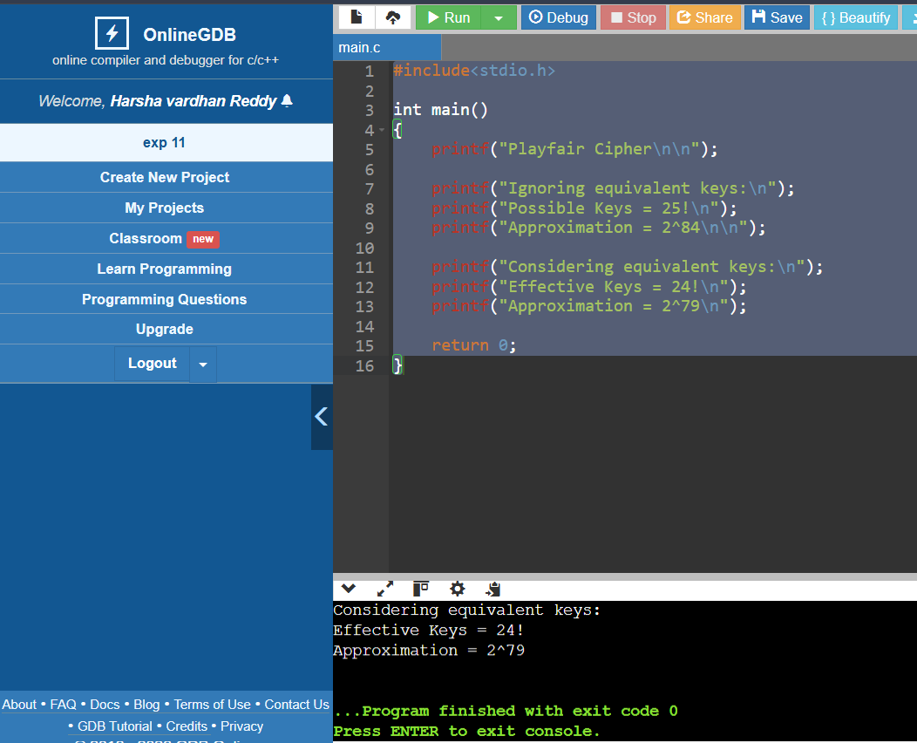

EXPERIMENT 12:
CODE:
#include<stdio.h>
#include<string.h>

int main()
{
int key[2][2]={{9,4},{5,7}};

char plain[100];

printf("Enter plaintext (even length): ");

scanf("%s",plain);

printf("Ciphertext: ");

for(int i=0;i<strlen(plain);i+=2)
{
int p1=plain[i]-'a';
int p2=plain[i+1]-'a';

int c1=(key[0][0]*p1+key[0][1]*p2)%26;
int c2=(key[1][0]*p1+key[1][1]*p2)%26;

printf("%c%c",c1+'a',c2+'a');
}

return 0;
}

OUTPUT:
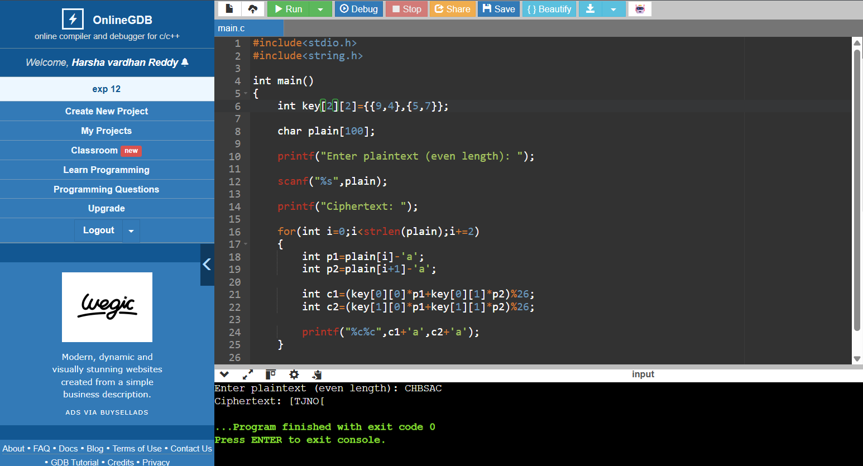
13TH EXPERIMENT:
CODE:
#include<stdio.h>

int main()
{
printf("Known Plaintext Attack on Hill Cipher\n\n");

printf("If attacker knows plaintext and ciphertext pairs,\n");
printf("they form matrix equation:\n\n");

printf("C = K * P (mod 26)\n\n");

printf("Using matrix inversion,\n");
printf("K = C * P^-1 (mod 26)\n\n");

printf("Hence Hill cipher is vulnerable.\n");

return 0;
}
OUTPUT:
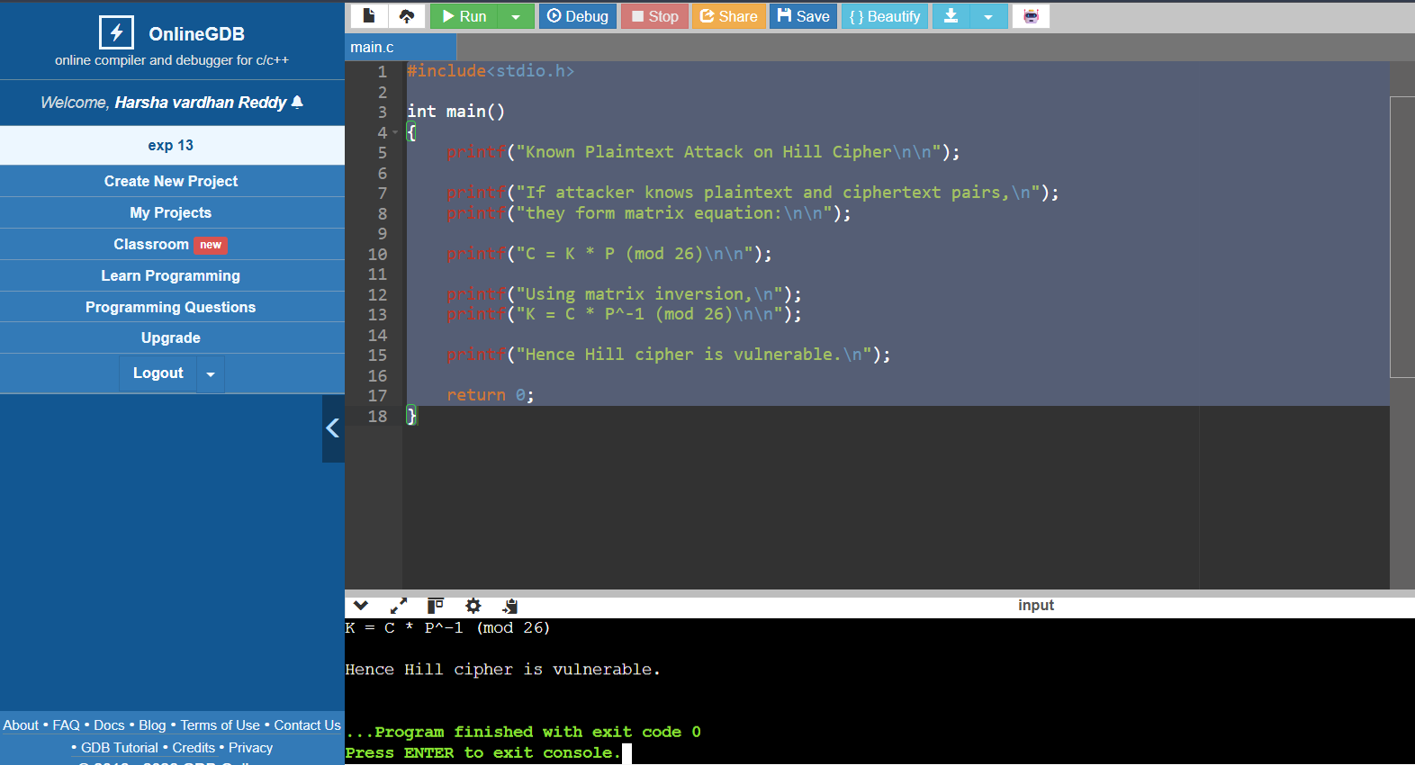

14TH EXPERIMENT:
CODE:
#include<stdio.h>
#include<string.h>

int main()
{
char plain[]="sendmoremoney";

int key[]={9,0,1,7,23,15,21,14,11,11,2,8,9};

printf("Ciphertext: ");

for(int i=0;i<13;i++)
{
int p=plain[i]-'a';

int c=(p+key[i])%26;

printf("%c",c+'a');
}

return 0;
}
OUTPUT:
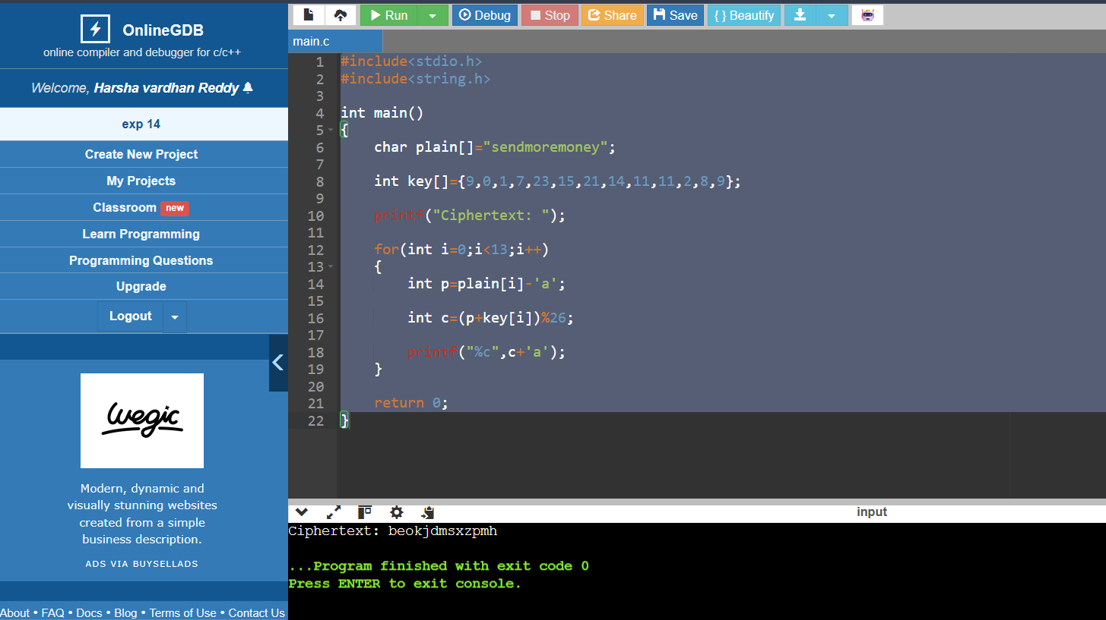
EXP 15:
CODE:
#include<stdio.h>
#include<string.h>
#include<ctype.h>

int main()
{
char cipher[500];
int top;

printf("Enter Ciphertext:\n");
gets(cipher);

printf("Enter number of possible plaintexts: ");
scanf("%d",&top);

if(top>26)
top=26;

for(int key=0;key<top;key++)
{
printf("\nKey %d : ",key);

for(int i=0;i<strlen(cipher);i++)
{
char ch=cipher[i];

if(isalpha(ch))
{
ch=toupper(ch);

ch=((ch-'A'-key+26)%26)+'A';
}

printf("%c",ch);
}

printf("\n");
}

return 0;
}
OUTPUT:
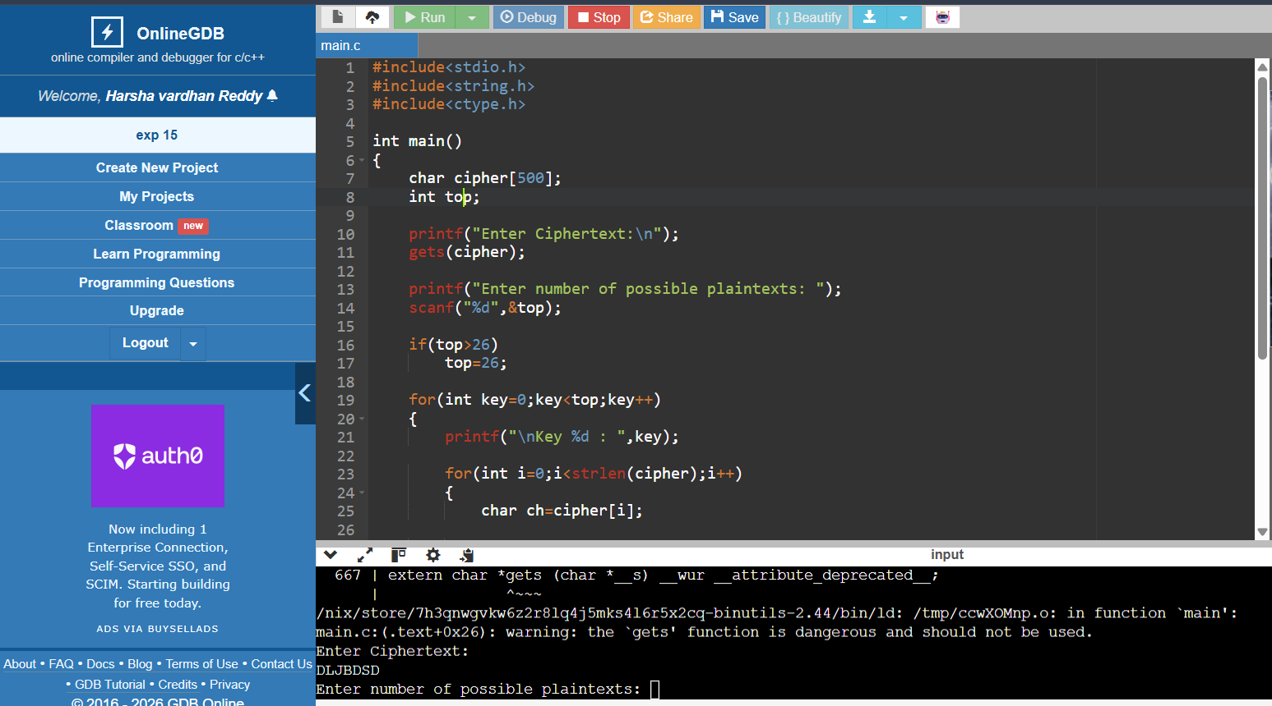

EXP 16:
CODE:
#include <stdio.h>
#include <string.h>
#include <ctype.h>

char englishFreq[] = "ETAOINSHRDLCUMWFGYPBVKJXQZ";

int main()
{
char cipher[1000];
int freq[26] = {0};
int index[26];
char map[26];

printf("Enter Ciphertext:\n");
fgets(cipher, sizeof(cipher), stdin);

int top;
printf("Enter number of possible plaintexts required: ");
scanf("%d",&top);

for(int i=0; cipher[i]; i++)
{
if(isalpha(cipher[i]))
freq[toupper(cipher[i])-'A']++;
}

for(int i=0;i<26;i++)
index[i]=i;

for(int i=0;i<25;i++)
{
for(int j=i+1;j<26;j++)
{
if(freq[index[j]]>freq[index[i]])
{
int t=index[i];
index[i]=index[j];
index[j]=t;
}
}
}

for(int i=0;i<26;i++)
map[index[i]]=englishFreq[i];

printf("\nPossible Plaintext (Frequency Attack)\n");

for(int i=0; cipher[i]; i++)
{
if(isalpha(cipher[i]))
printf("%c",map[toupper(cipher[i])-'A']);
else
printf("%c",cipher[i]);
}

printf("\n");

return 0;
}
OUTPUT:
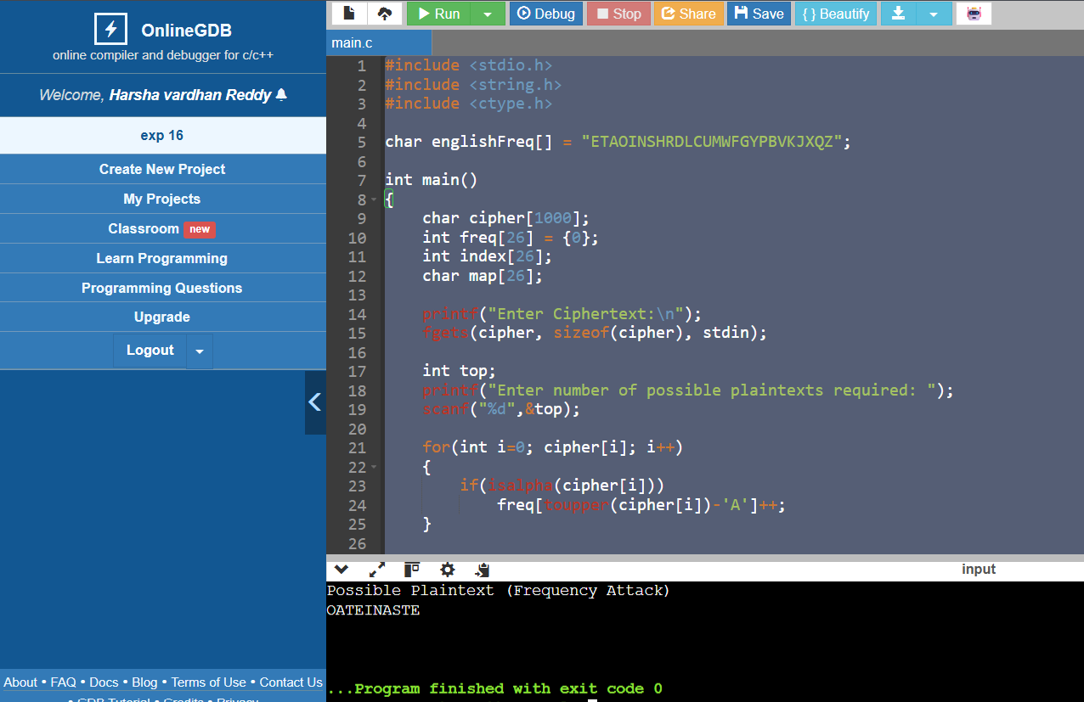
EXP 17:
CODE:
#include <stdio.h>

int main()
{
int keys[16];

printf("Enter 16 subkeys:\n");

for(int i=0;i<16;i++)
scanf("%d",&keys[i]);

printf("\nOrder of Keys for Decryption\n");

for(int i=15;i>=0;i--)
printf("K%d = %d\n",i+1,keys[i]);

return 0;
}
OUTPUT:
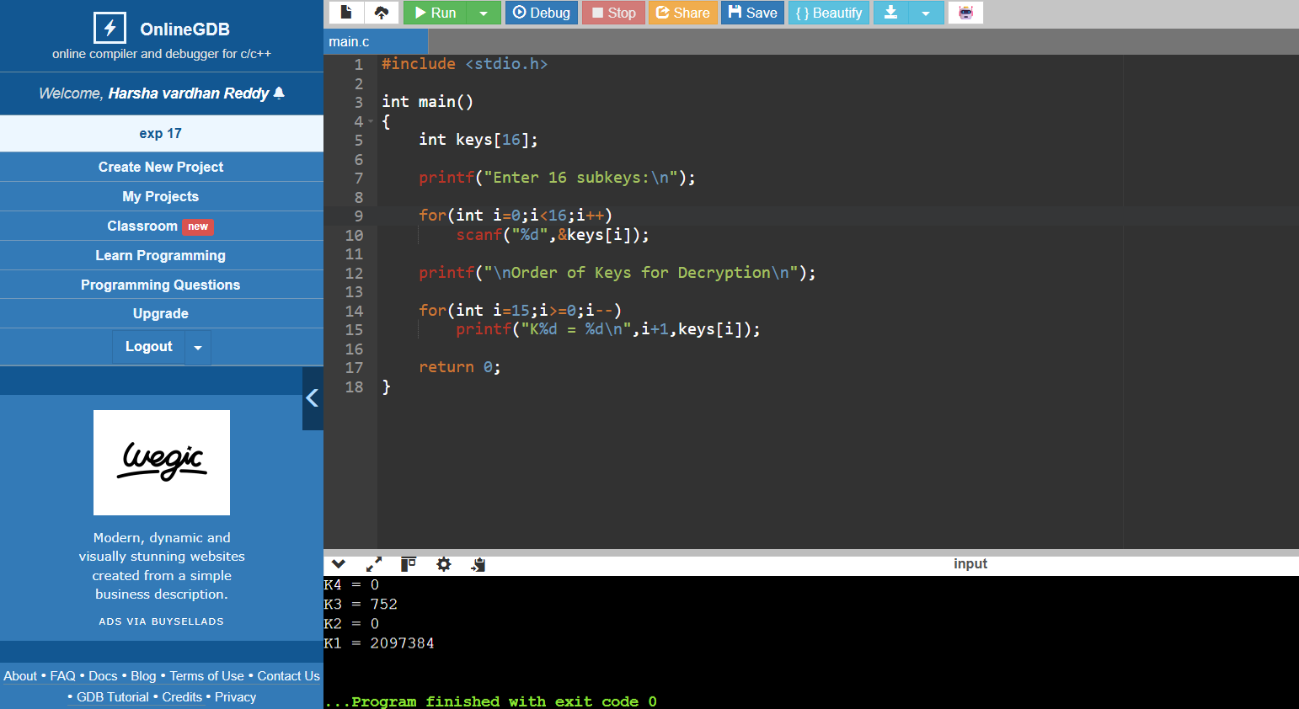

EXP 18:
CODE:
#include <stdio.h>

int main()
{
printf("DES Key Generation\n\n");

printf("56-bit key\n");
printf(" |\n");
printf("Split into C0 and D0 (28 bits each)\n");
printf(" |\n");
printf("Left Circular Shift\n");
printf(" |\n");
printf("Apply PC-2\n");
printf(" |\n");
printf("48-bit Round Key\n\n");

printf("First 24 bits <- C half\n");
printf("Second 24 bits <- D half\n");

return 0;
}
OUTPUT:
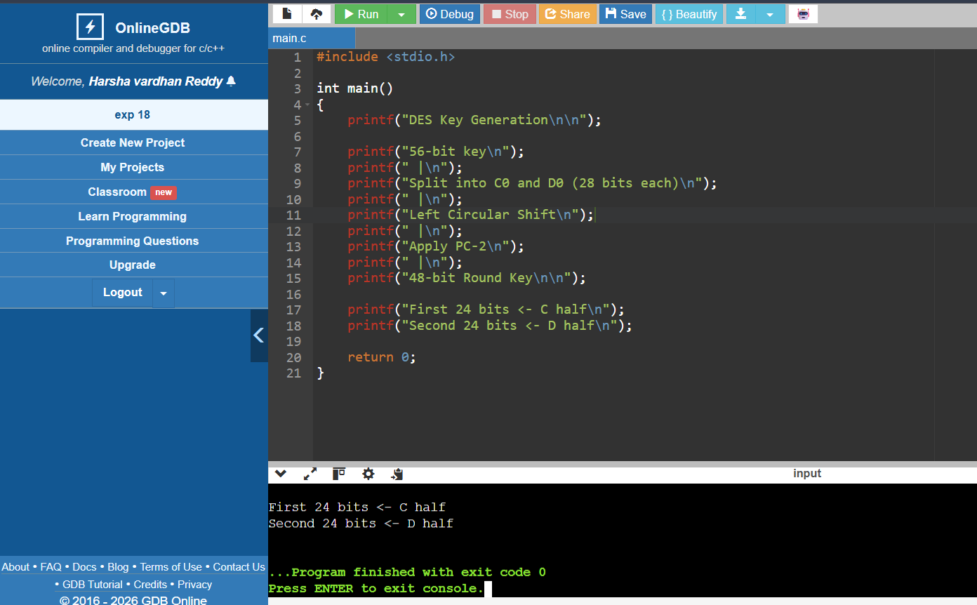

EXP 19:
CODE:
#include <stdio.h>

unsigned char encrypt(unsigned char p,unsigned char key)
{
return p^key;
}

int main()
{
unsigned char key=0x5A;
unsigned char iv=0xAA;

unsigned char plaintext[4]={10,20,30,40};
unsigned char cipher[4];

unsigned char prev=iv;

for(int i=0;i<4;i++)
{
cipher[i]=encrypt(plaintext[i]^prev,key);
prev=cipher[i];
}

printf("Ciphertext:\n");

for(int i=0;i<4;i++)
printf("%02X ",cipher[i]);

return 0;
}
Output:
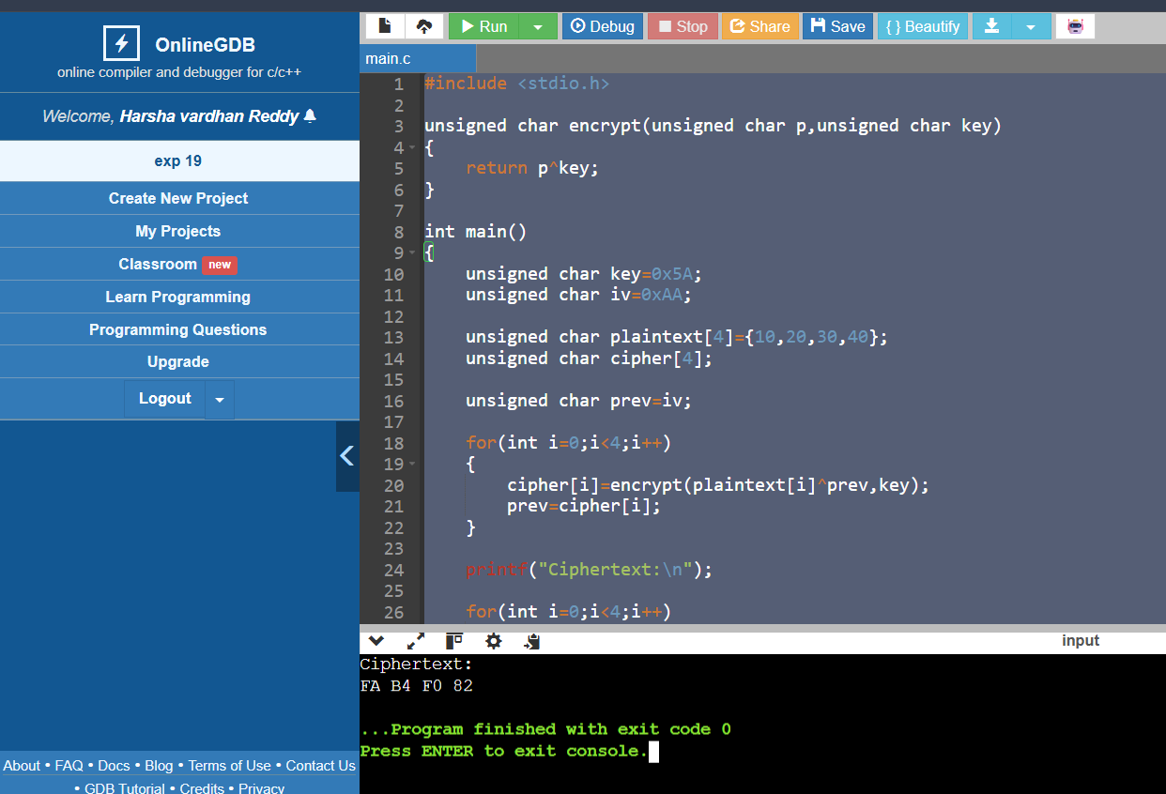
EXP 20:
CODE:
#include <stdio.h>

#define SIZE 4

// Toy encryption/decryption using XOR
unsigned char encrypt(unsigned char data, unsigned char key)
{
return data ^ key;
}

unsigned char decrypt(unsigned char data, unsigned char key)
{
return data ^ key;
}

int main()
{
unsigned char key = 0x5A;
unsigned char iv = 0xAA;

unsigned char plaintext[SIZE] = {10, 20, 30, 40};

unsigned char ecbCipher[SIZE], ecbPlain[SIZE];
unsigned char cbcCipher[SIZE], cbcPlain[SIZE];

int i;

/* ---------- ECB Encryption ---------- */
for(i = 0; i < SIZE; i++)
ecbCipher[i] = encrypt(plaintext[i], key);

/* Introduce an error in the first ciphertext block */
ecbCipher[0] ^= 0x01;

/* ECB Decryption */
for(i = 0; i < SIZE; i++)
ecbPlain[i] = decrypt(ecbCipher[i], key);

printf("ECB Mode\n");
printf("Recovered Plaintext:\n");
for(i = 0; i < SIZE; i++)
printf("%d ", ecbPlain[i]);

printf("\n\n");

/* ---------- CBC Encryption ---------- */
unsigned char prev = iv;

for(i = 0; i < SIZE; i++)
{
cbcCipher[i] = encrypt(plaintext[i] ^ prev, key);
prev = cbcCipher[i];
}

/* Introduce an error in first ciphertext block */
cbcCipher[0] ^= 0x01;

/* CBC Decryption */
prev = iv;

for(i = 0; i < SIZE; i++)
{
cbcPlain[i] = decrypt(cbcCipher[i], key) ^ prev;
prev = cbcCipher[i];
}

printf("CBC Mode\n");
printf("Recovered Plaintext:\n");
for(i = 0; i < SIZE; i++)
printf("%d ", cbcPlain[i]);

return 0;
}
OUTPUT:
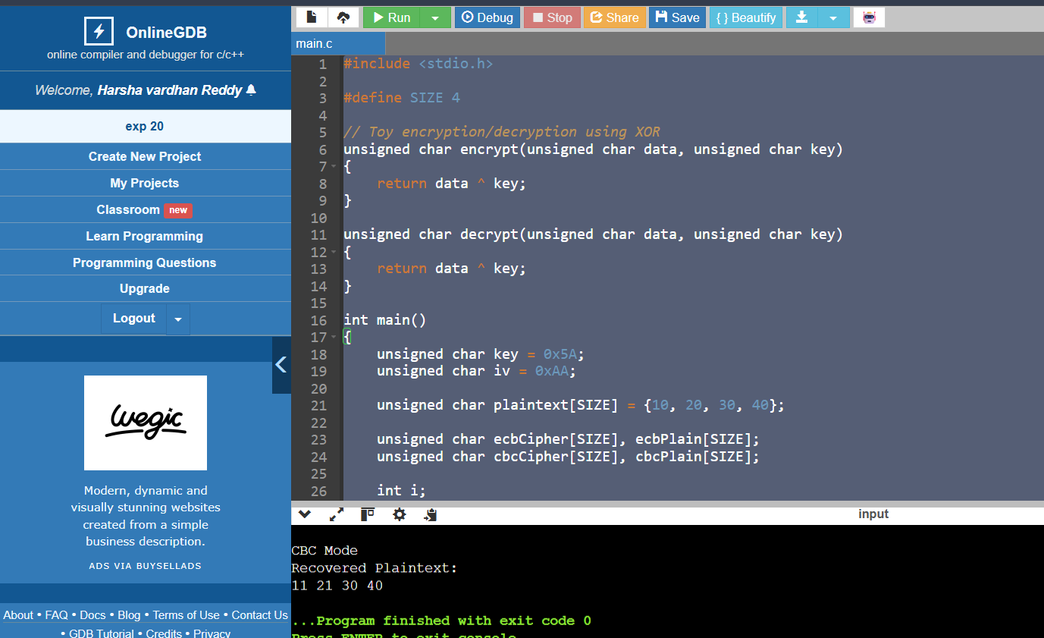

EXP 21:
CODE:
#include <stdio.h>
#include <string.h>
#define BLOCK_SIZE 8
void printBlock(unsigned char block[]) {
for (int i = 0; i < BLOCK_SIZE; i++)
printf("%02X ", block[i]);
printf("\n");
}
void encryptBlock(unsigned char input[], unsigned char key[], unsigned char output[]) {
for (int i = 0; i < BLOCK_SIZE; i++)
output[i] = input[i] ^ key[i];
}
void decryptBlock(unsigned char input[], unsigned char key[], unsigned char output[]) {
for (int i = 0; i < BLOCK_SIZE; i++)
output[i] = input[i] ^ key[i];
}
void ECB(unsigned char plaintext[][BLOCK_SIZE], int blocks, unsigned char key[]) {
unsigned char cipher[BLOCK_SIZE];
printf("\nECB Encryption:\n");
for (int i = 0; i < blocks; i++) {
encryptBlock(plaintext[i], key, cipher);
printf("Block %d: ", i + 1);
printBlock(cipher);
}
}
void CBC(unsigned char plaintext[][BLOCK_SIZE], int blocks, unsigned char key[], unsigned char iv[]) {
unsigned char temp[BLOCK_SIZE], cipher[BLOCK_SIZE];
memcpy(temp, iv, BLOCK_SIZE);
printf("\nCBC Encryption:\n");
for (int i = 0; i < blocks; i++) {
for (int j = 0; j < BLOCK_SIZE; j++)
temp[j] ^= plaintext[i][j];
encryptBlock(temp, key, cipher);
printf("Block %d: ", i + 1);
printBlock(cipher);
memcpy(temp, cipher, BLOCK_SIZE);
}
}
void CFB(unsigned char plaintext[][BLOCK_SIZE], int blocks, unsigned char key[], unsigned char iv[]) {
unsigned char feedback[BLOCK_SIZE];
unsigned char cipher[BLOCK_SIZE];
unsigned char temp[BLOCK_SIZE];
memcpy(feedback, iv, BLOCK_SIZE);
printf("\nCFB Encryption:\n");
for (int i = 0; i < blocks; i++) {
encryptBlock(feedback, key, temp);
for (int j = 0; j < BLOCK_SIZE; j++)
cipher[j] = plaintext[i][j] ^ temp[j];
printf("Block %d: ", i + 1);
printBlock(cipher);
memcpy(feedback, cipher, BLOCK_SIZE);
}
}
int main() {
unsigned char key[BLOCK_SIZE] = {
'K','E','Y','1','2','3','4','5'
};
unsigned char iv[BLOCK_SIZE] = {
'I','N','I','T','V','E','C','1'
};
unsigned char plaintext[2][BLOCK_SIZE] = {
{'A','B','C','D','E','F','G','H'},
{'1','2','3','4','5','6','7','8'}
};
ECB(plaintext, 2, key);
CBC(plaintext, 2, key, iv);
CFB(plaintext, 2, key, iv);
return 0;
}
OUTPUT:

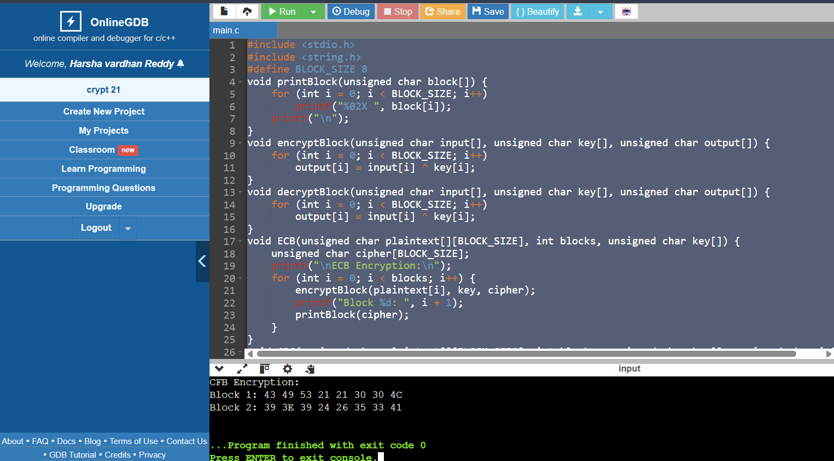

EXP 22:
CODE:

